Journal: Ecology
Article Title: Interpreting field measurements of juvenile growth and survival rates with population growth isoclines
Authors: Nathan T. Barrus, Mark I. Cook & Nathan J. Dorn.

Appendix S3: Environmental Conditions
LILA hydrologic experiment
The water levels in LILA are controlled by pumps and culverts to perform landscape-scale hydrologic experiments. Wetlands M1 & M3 were managed for an unconstrained hydrologic treatment while M2 & M4 were managed for a constrained hydrologic treatment. The unconstrained wetlands are generally deeper than constrained wetlands and depths rise faster in the wet season although wetlands reach the same low water levels in the dry season (Figure S1; below). Shallower water levels are generally favorable for FAS reproduction (Barrus et al., 2023), we refer to the deeper unconstrained hydrologic treatment as “poor reproduction” and the shallower constrained hydrologic as the “good reproduction” hydrologic treatment in the manuscript. The depth flux in LILA are realistic conditions experienced within the natural Everglades landscape but their net effects on population growth are less clear than their impacts on reproduction.
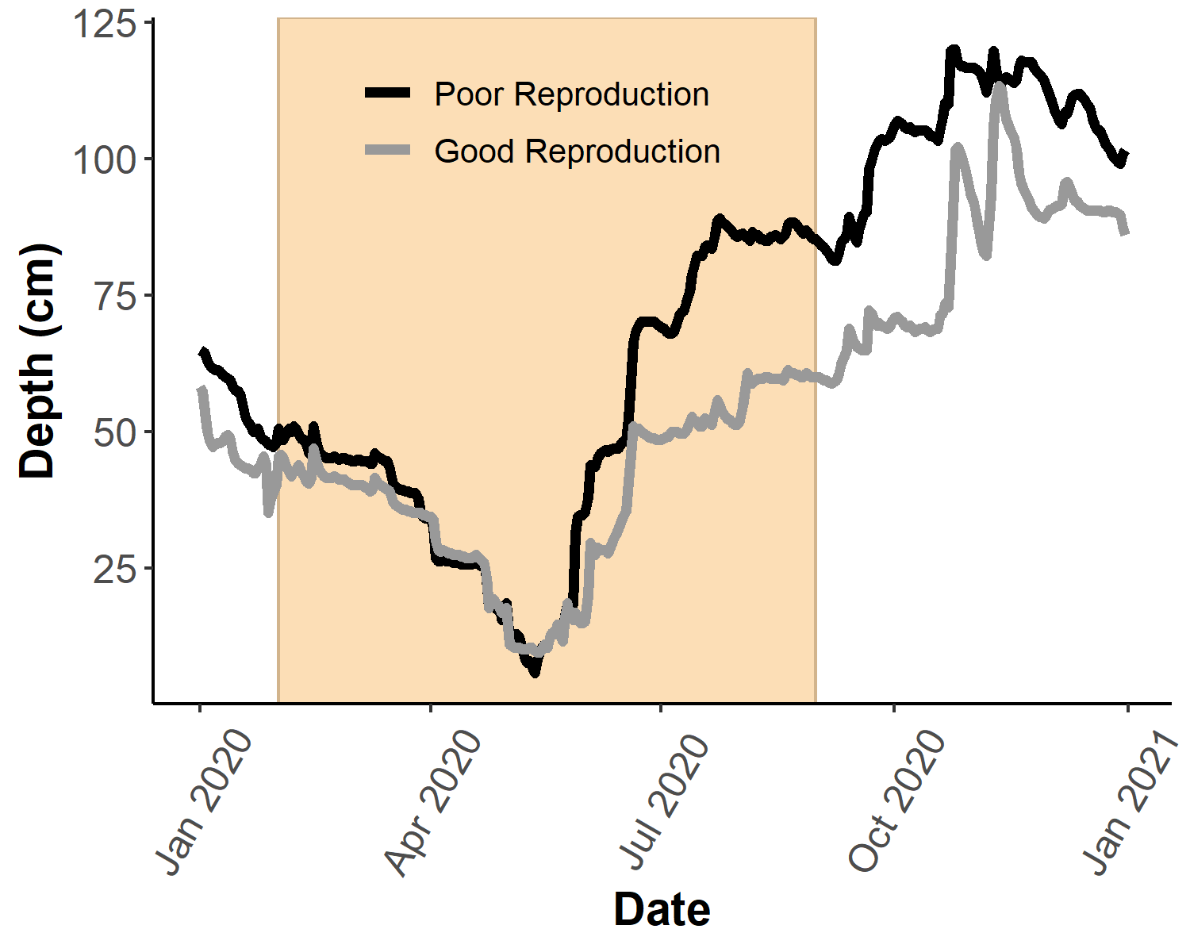
Figure S1: The hydrologic treatments in LILA in 2020. Shaded Area represents the Florida apple snail reproductive season.

WCA3A site level total phosphorus
Table S1: site level differences in periphyton total phosphorus in WCA3A.
Site | Season | n_{samples} | Total Phosphorus (μg·g⁻¹)
 |  |  | mean | sd | CI (min,max)
Site 2 | wet | 2 | 410.83 | 21.10 | (381.59, 440.07)
Site 3 | wet | 2 | 121.94 | 23.13 | (89.89, 153.99)

Seasonal Growth and Temperature
Size-specific growth rates in the wet season (month) were greater than those in the dry season (month, Figure S1). Water temperatures were also warmer in the wet season than in the dry season (Figure S1). Seasonal growth measurements in the WCA wetlands showed qualitatively similar patterns with higher growth in the wet season and lower growth rates in the dry season.

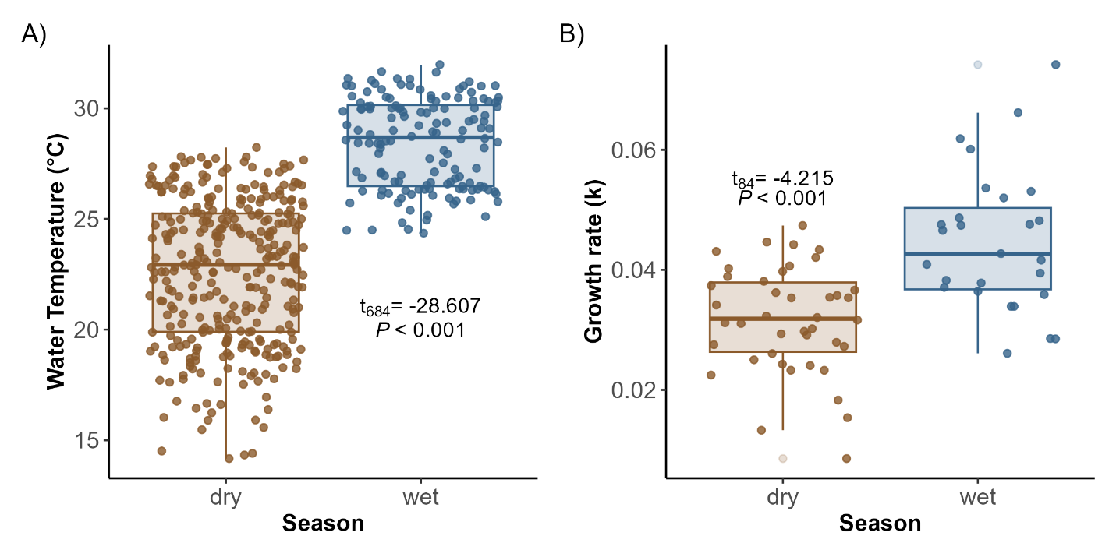
Figure S2: Seasonal A) daily water temperatures and B) Florida apple snail juvenile growth in the LILA wetlands of the Everglades. Each point in panel B represents an individual snail.

References
Barrus, N. T., Drumheller, D., Cook, M. I., & Dorn, N. J. (2023). Life history responses of two co-occurring congeneric Apple Snails (Pomacea maculata and P. paludosa) to variation in water depth and metaphyton total phosphorus. Hydrobiologia, 850(4), 841–860. https://doi.org/10.1007/s10750-022-05128-9

